**Punnett square practice**

1. In dogs, the gene for fur color has two alleles. The dominant allele (F) codes for grey fur and the recessive allele (f) codes for black fur. The female dog is heterozygous. The male dog is homozygous recessive. Figure out the percentage or ratio of possible phenotypes and genotypes of their puppies by using a Punnett Square



Female Ff Male ff

50% black

50%grey



1. Patty is homozygous dominant for freckles (SS), while Charlie is homozygous for no freckles (ss). Draw a Punnett square predicting the probability if their children will have freckles.



100% freckles



1. In dogs, there is a hereditary deafness caused by a recessive gene, “d.” A kennel owner has a male dog (Gilbert) that she wants to use for breeding purposes if possible. The dog can hear. What are the two possible genotypes of Gilbert?



If the dog’s genotype is Dd, the owner does not wish to use him for breeding so that the deafness gene will not be passed on. This can be tested by breeding the dog to a deaf female (dd). Fill in these two Punnett squares to illustrate the crosses for your possible male genotypes with the deaf female dog

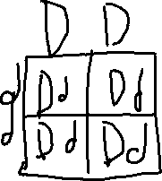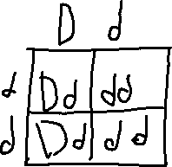

100% can hear

0% deaf

50% can hear

50% deaf

1. A tall green pea plant (TtGg) is crossed with a short green pea plant (ttGg).

TT or Tt = tall tt = short GG or Gg = green gg = white

What is the probability of having a tall white pea plant?

3/8 tall white plant or 0.375 %

25% white

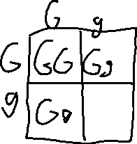

50% tall

